**Q) Provide the trend chart for the number of complaints at monthly and daily granularity levels.**

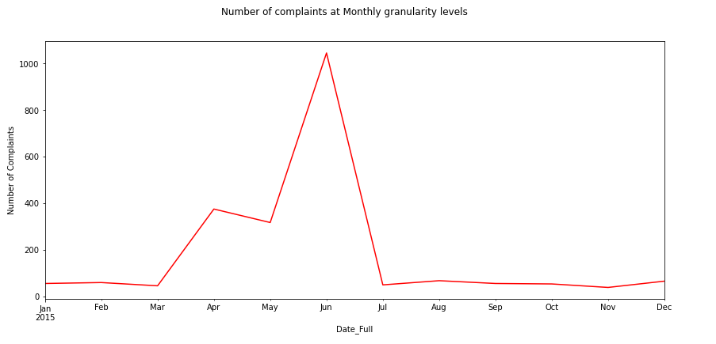

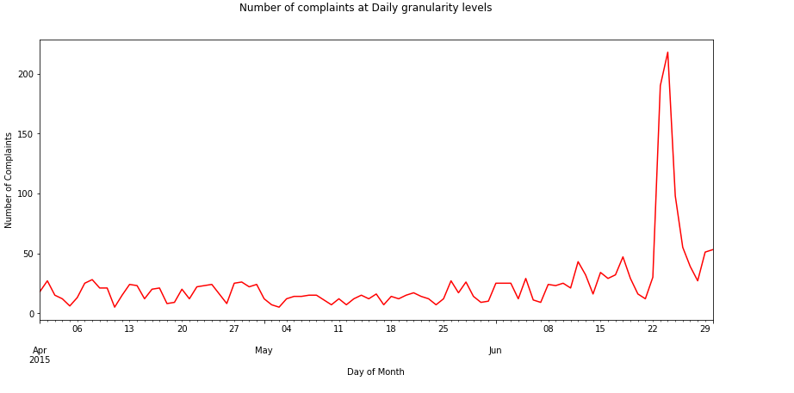

**Q) Provide a table with the frequency of complaint types.**

COMCAST 102

COMCAST DATA CAP 30

COMCAST INTERNET 29

COMCAST DATA CAPS 21

COMCAST BILLING 18

COMCAST SERVICE 15

INTERNET SPEED 15

UNFAIR BILLING PRACTICES 13

DATA CAPS 13

DATA CAP 12

COMCAST/XFINITY 11

COMCAST COMPLAINT 11

COMCAST INTERNET SERVICE 10

BILLING 9

BILLING ISSUES 8

COMCAST CABLE 5

COMCAST BILLING COMPLAINT 5

COMCAST ISSUES 5

COMPLAINT AGAINST COMCAST 5

SLOW INTERNET 5

SERVICE ISSUES 5

INTERNET 5

INTERNET SERVICE 5

COMCAST BILLING PRACTICES 5

COMCAST BILLING ISSUES 4

**Q) Which complaint types are maximum**

| **New_Status** | **Closed** | **Open** |
| --- | --- | --- |
| **State** |  |  |
| **Alabama** | 17 | 9 |
| **Arizona** | 14 | 6 |
| **Arkansas** | 6 | 0 |
| **California** | 159 | 61 |
| **Colorado** | 58 | 22 |
| **Connecticut** | 9 | 3 |
| **Delaware** | 8 | 4 |
| **District Of Columbia** | 14 | 2 |
| **District of Columbia** | 1 | 0 |
| **Florida** | 201 | 39 |
| **Georgia** | 208 | 80 |
| **Illinois** | 135 | 29 |
| **Indiana** | 50 | 9 |
| **Iowa** | 1 | 0 |
| **Kansas** | 1 | 1 |
| **Kentucky** | 4 | 3 |
| **Louisiana** | 12 | 1 |
| **Maine** | 3 | 2 |
| **Maryland** | 63 | 15 |
| **Massachusetts** | 50 | 11 |
| **Michigan** | 92 | 23 |
| **Minnesota** | 29 | 4 |
| **Mississippi** | 23 | 16 |
| **Missouri** | 3 | 1 |
| **Montana** | 1 | 0 |
| **Nevada** | 1 | 0 |
| **New Hampshire** | 8 | 4 |
| **New Jersey** | 56 | 19 |
| **New Mexico** | 11 | 4 |
| **New York** | 6 | 0 |
| **North Carolina** | 3 | 0 |
| **Ohio** | 3 | 0 |
| **Oregon** | 36 | 13 |
| **Pennsylvania** | 110 | 20 |
| **Rhode Island** | 1 | 0 |
| **South Carolina** | 15 | 3 |
| **Tennessee** | 96 | 47 |
| **Texas** | 49 | 22 |
| **Utah** | 16 | 6 |
| **Vermont** | 2 | 1 |
| **Virginia** | 49 | 11 |
| **Washington** | 75 | 23 |
| **West Virginia** | 8 | 3 |

**Q) Provide state wise status of complaints in a stacked bar chart. Use the categorized variable from Q3. Provide insights on:**

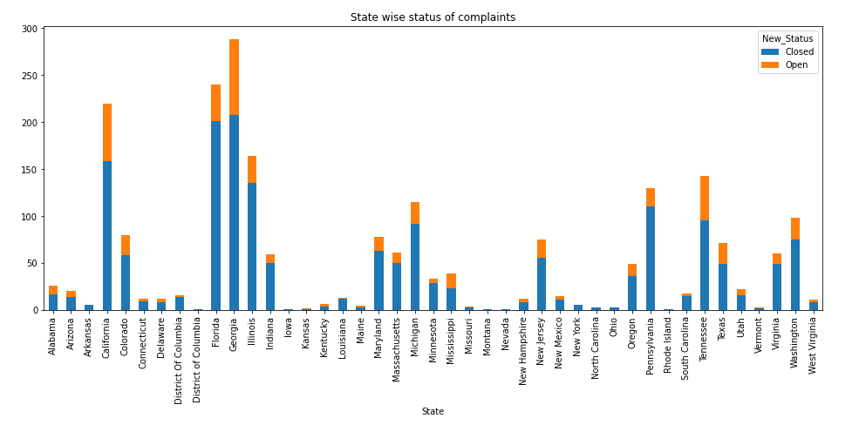

**Q) Which state has the maximum complaints**



**Q) Which state has the highest percentage of unresolved complaints**

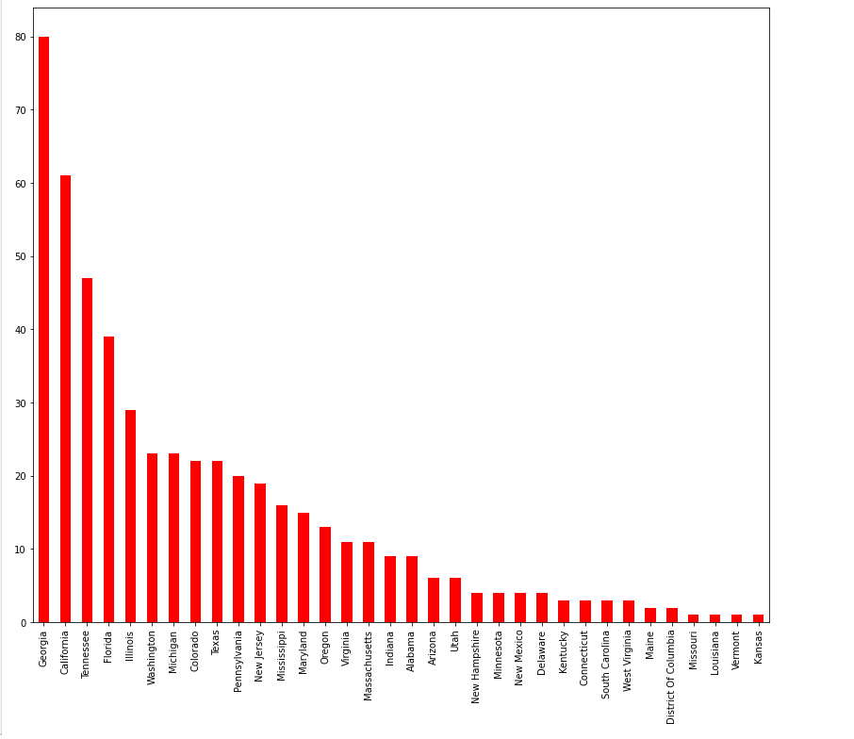

**Q) Provide the percentage of complaints resolved till date, which were received through the Internet and customer care calls.**

